NYS Abolition through Data Analysis Student Handout
New York State Abolition Lessons
Lehman Center for American History

PART I
In small groups, answer the questions about your assigned data sets. Be prepared to teach other classmates about the data sets you analyzed.

GROUP A (Analyze Chart A and Graph A)
Chart A: Total number of captives embarked and disembarked, including vessel flag (1630-1775) *U.S.A refers to the colonies*

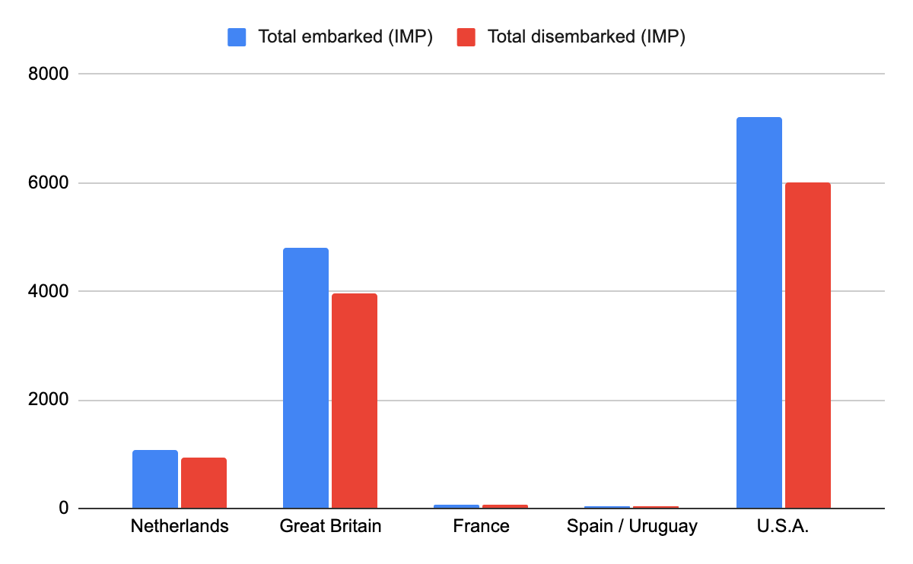

Graph A: Total number of captives embarked and disembarked, years of arrival in NY
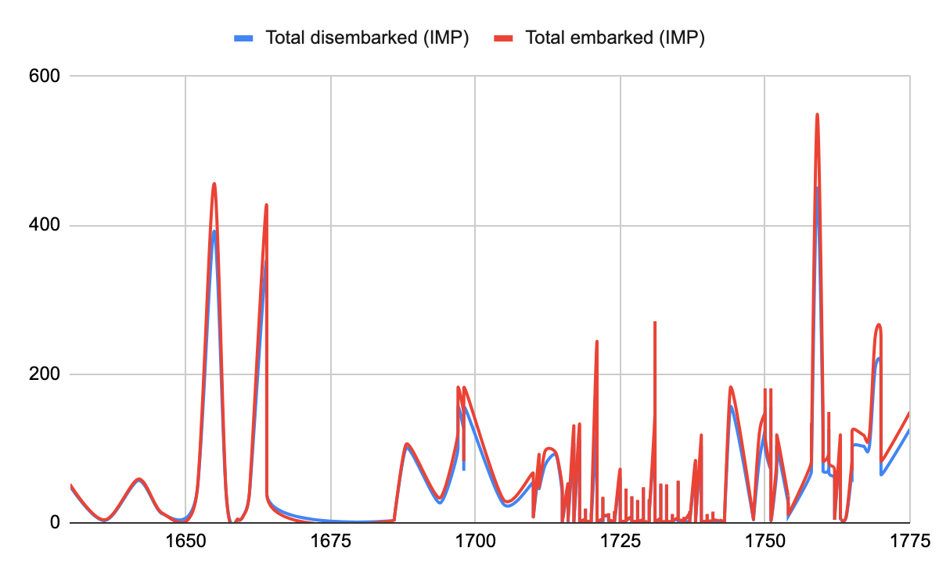

Questions:

- Out of all of the documented slave voyages that ended in NY, under which flag was the greatest overall number of captives to arrive?

- Out of all of the documented slave voyages that ended in NY, in what years was the slave trade into NY at its peak?

- What do you observe in chart A? Write at least five observations.

- What do you observe in graph A? Write at least five observations.

- What information do we gain from these data sets?

- What are the advantages of conveying this information in a chart versus a graph? And vice versa?

- What information do we not learn from these data sets?

- What questions do you still have? Write as many as you can.
GROUP B (Analyze Table B and Chart B)
Table B: Number of Enslaved People by Gender in New York County Wards in 1810

Locality | Adult Male | Adult Female
Eighth Ward | 50 | 92
Fifth Ward | 86 | 141
First Ward | 230 | 287
Fourth Ward | 22 | 42
Ninth Ward | 101 | 132
Second Ward | 44 | 100
Seventh Ward | 24 | 52
Sixth Ward | 48 | 51
Tenth Ward | 31 | 62
Third Ward | 95 | 176

Chart B: Number of Enslaved People by Gender in New York County Wards in 1810
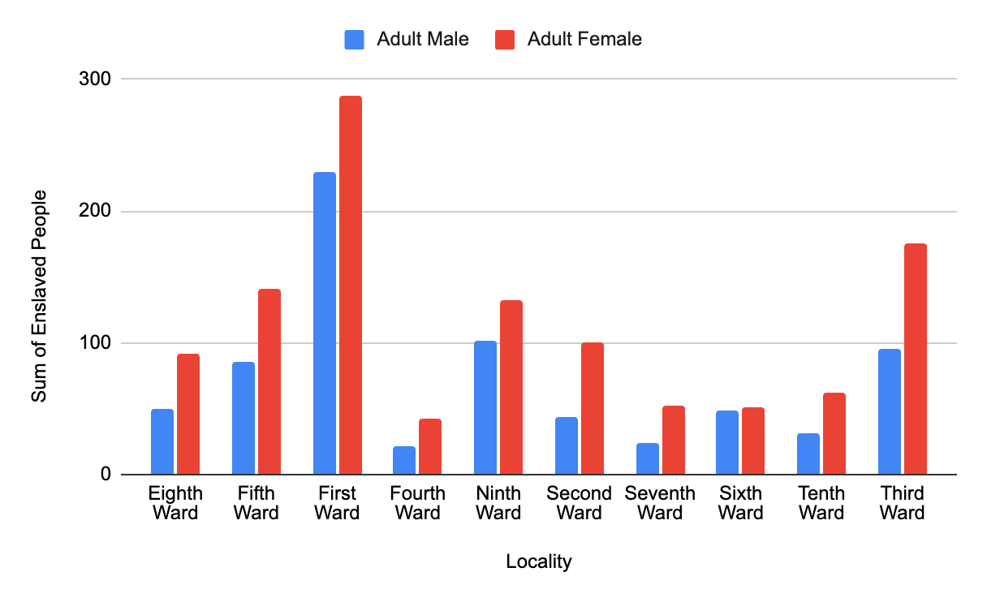

Questions:

- Of all the New York County Wards, which had the fewest adult women in 1810?

- Of all the New York County Wards, which had the second-fewest adult men in 1810?

- What do you observe in Table B? Write at least five observations.

- What do you observe in Chart B? Write at least five observations.

- What information do we gain from these data sets?

- What are the advantages of conveying this information in a table versus a chart? And vice versa?

- What information do we not learn from these data sets?

- What questions do you still have? Write as many as you can.

GROUP C (Analyze Table C and Graph C)

Table C: Sum of Enslaved People Across Five Counties from 1790-1830 (Household Census Data)

Year of Census | New York | Bronx | Queens | Kings | Richmond
1790 | 2350 | 205 | 2250 | 1545 | 765
1800 | 2701 | 148 | 1383 | 1488 | 650
1810 | 1720 | 99 | 838 | 1118 | 435
1820 | 618 | 32 | 605 | 850 | 548
1830 | 28 |  | 1

Graph C: Sum of Enslaved People Across Five Counties from 1790-1830 (Household Census Data)
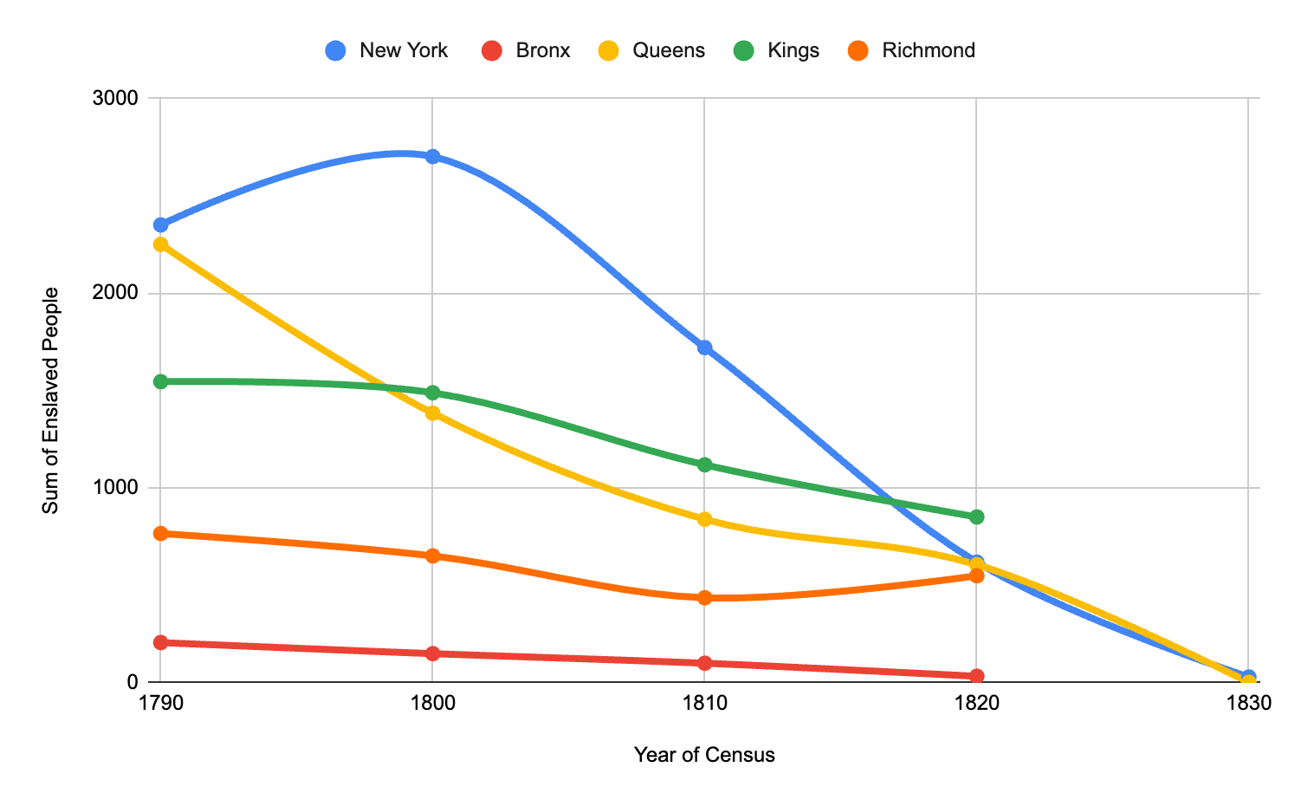

Questions:

- In what year did Bronx County have its highest number of enslaved people?

- Which county had the lowest number of enslaved people in 1830?

- What do you observe in Table C? Write at least five observations.

- What do you observe in Chart C? Write at least five observations.

- What information do we gain from these data sets?

- What are the advantages of conveying this information in a table versus a graph? And vice versa?

- What information do we not learn from these data sets?

- What questions do you still have? Write as many as you can.

PART II
In your new groups, discuss the following questions and take notes on what your peers teach you.

- What is one piece of information each person learned from the data sets that surprised them?

- What types of information can we learn from these data sets? What information can we not gather from them?

- How does the type of way we display data inform the conclusions we can draw? In other words, are there particular pieces of information we can see when we look at a chart versus another format, for instance?

- What is one compelling question each person wants to explore further based on their data sets?

